

Masters Programmes

Group Work Assignment Cover Sheet

Submitted by: 2135348, 2114807, 2048442, 1808375, 1663053, 0933202

Group Number: 2

Date: 17/03/2022

Module Title: Advanced Analytics: Models and Applications

Module Code: IB9190

Date/Year of Module: Term 2/2022

Submission Deadline: 17/03/2022

Word Count: 1995 words

Number of Pages: 4

Question: Advanced Analytics 2022 – Group Assignment

I declare that this work is being submitted on behalf of my group, in accordance with the University's Regulation 11 and the WBS guidelines on plagiarism and collusion. All external references and sources are clearly acknowledged and identified within the contents. No substantial part(s) of the work submitted here has also been submitted in other assessments for accredited courses of study and if this has been done it may result in us being reported for self-plagiarism and an appropriate reduction in marks may be made when marking this piece of work.

Task 1
All information below is based on Cohen et al. (2017).

Data and parameters:
$$T$$ | The number of time periods in the optimization period.
$$L$$ | Maximum number of promotions within the optimization period.
$$S$$ | Minimal number of time periods between two consecutive promotions.
$$Q$$ | = { $q^{0}>q^{1}>…q^{k}>…q^{K}$ } the price ladder containing every allowed retail price.
$$q^{0}$$ | Price without promotion/discount (i.e., baseline price).
$$q^{k}$$ | The $k^{th}$highest price in the price ladder. Promotional price where $k∈\left\{1,2,…,K\right\}$. K is the number of discounted price levels.
$$c_{t}$$ | The unit cost of the product at time t.
$$M$$ | Memory parameter of demand with respect to prices, i.e. the number of periods behind that past prices affect present demand

Decision Variables:
$$γ_{t}^{k}∈\left\{0,1\right\} ∀t,k$$

$γ_{t}^{k}$is a binary variable that is equal to 1 if element k of the price ladder is chosen at time t, and 0 otherwise. There are $|Q|×T$ decision variables.

Objective function:
$\max_{γ_{t}^{k}}{\sum_{t=1}^{T}{{\left(p_{t}-c_{t}\right)d}_{t}\left(p_{t}\right)}}$

The objective function for the promotion optimization problem (POP) maximises total profit over T time periods. Profit in period t is the selling price of the product at time t ($p_{t}$) minus the cost of the product at time t ($c_{t}$) multiplied by the quantity sold at time t. The authors assumed that the quantity sold is equal to the demand for the product $d_{t}\left(p_{t}\right)$. Given the empirically observed post-promotion dip, $\left(p_{t}\right)$ is a vector of prices over (t - M, t) periods, where M is the extent to which past prices affect current demand.

Constraints:
$p_{t}=\sum_{k=0}^{K}{q^{k}}γ_{t}^{k}$ | - Links between selling prices and decision variables
$\sum_{t=1}^{T}{\sum_{k=1}^{K}{γ_{t}^{k}}}≤ L$ | - Limited number of promotions
$\sum_{τ=t}^{t+S}{\sum_{k=1}^{K}{γ_{t}^{k}}}≤ 1 ∀_{t}$ | - Minimum time gap between two consecutive promotions
$\sum_{k=0}^{K}{γ_{t}^{k}}=1 ∀_{t}$ | - One selling price chosen from the price ladder in every period
Constraint (1) indicates that the selling price ($p_{t}$) at time t is the $k^{th}$element of the price ladder where the decision variable $γ_{t}^{k}$ =1. It links the decision variables $γ_{t}^{k}$ to the objective function, where only $p_{t}$ is featured.

Constraint (2) limits the total number of promotions at L, within the optimisation period.

Constraint (3) specifies that within the range of time periods (t, t + S), there can be at most one period with a selling price below the baseline. This is a rolling constraint that applies to all t $∈$ {1, 2, … T}.

Constraint (4) specifies that exactly one price level needs to be chosen at any period t.
Task 2
All the constraints in IP in Section 4 are constraints on when promotions can be implemented. There are no specific constraints on the depth of the promotion (the promotion price). Therefore, the optimisation problem is free to choose, and would choose the price that maximises profit in a given time period if a promotion was to be implemented (i.e., $γ_{t}^{k}$ =1 for k $∈$ {1, 2, … K} maximising expected profit at time t). This is equivalent to identifying $\max_{k=1, …K} b_{t}^{k}= {\tilde{b}}_{t}$ for each period t, where $b_{t}^{k}$= POP($p_{t}^{k}$) – POP($p^{0}$) as in equation 6 of Cohen et al. (2017), and then letting the optimisation problem choose which time period(s) to implement promotions. The key simplification of the CIP versus the IP is to separate the decisions of the price level from the selection of the promotion time period(s). This relies on the fact that the IP problem was designed to ignore the interactive effects between promotions due to the empirically observed promotion price dip effect.

Since$b_{t}^{k}$ is a discrete set of coefficients, choosing the set maximum for every period can be computed in linear time. Additionally, in the CIP formulation, there are only $T$ decision variables as opposed to $|Q|×T$, reducing the dimensionality of the problem. The constraints in CIP are also simplified from those in IP and require summation across fewer decision variables. This way, the constraint matrix also gains the significant property of “consecutive ones” (Cohen et al. (2017, p.455)), which allows the linear relaxation of the problem to yield optimal integer results. Thus, the CIP is not only a smaller, more efficiently computable integer program, but can also be solved as a linear program that requires significantly less time to solve.

Task 3
Store 32 was chosen randomly to estimate the demand functions for both types of cream cheese. Equation 18 of Cohen et al. (2017) is re-parametrized to the model below so that it could be estimated using a pooled panel regression to accommodate common seasonality and trend effects, but differing intercepts and price effects across the brands.
$$\log\left(d_{it}\right)= β_{1}^{0}+ β_{2}^{0}{PHILA}_{i}+β^{1}t+\sum_{j=2}^{52}{β_{j}^{2}}{week_in_year}_{t}+\sum_{m=0}^{M}{β_{m}^{3}}\log\left({price}_{t}\right) +\sum_{m=0}^{M}{β_{m}^{3^{'}}}\log{({price}_{t})}*{PHILA}_{i}+ϵ_{it}$$

To show equivalence between the model formulations, the $β_{im}^{3}$ coefficients in Cohen et al. (2017) can be attained as below.
$$β_{im}^{3}=\left\{\begin{aligned}β_{m}^{3}, &if{PHILA}_{i}=0 \\ β_{m}^{3}+β_{m}^{3^{'}}, &if {PHILA}_{i}=1\end{aligned}\right.$$

Model variables were transformed from variables in the provided data set (Appendix 1):

$${PHILA}_{i}$$ | Based on UPC; 1 if UPC = 2100061223, 0 otherwise
$$t$$ | Based on WEEK column as time indices
$${week_in_year}_{t}$$ | Week of the year for weekly seasonality
$$\log\left(d_{it}\right)$$ | logarithm of MOVE for cheese brand (i) in period (t)
$$\log\left({price}_{t}\right)$$ | logarithm of PRICE for cheese brand (i) in period (t)

The model was estimated using the first 85% of time periods in the data set and tested on the remaining 15% of time periods.

Based on section 7.2 of Cohen et al. (2017), we hypothesised that the memory parameter could be greater than 0 but is unlikely to be large. Therefore, the regression model was estimated for M between 0 and 4 (both inclusive). The models were then compared using the mean absolute percentage error measure (MAPE) as in Cohen et al. (2017). The MAPE scores are in Table 1 below.

Table 1. Mean absolute percentage errors for log-demand models
M | MAPE for Philadelphia | MAPE for DOM | MAPE for both brands
0 | 0.3903 | 0.4777 | 0.4340
1 | 0.3621 | 0.4742 | 0.4182
2 | 0.3573 | 0.4727 | 0.4150
3 | 0.3532 | 0.4762 | 0.4147
4 | 0.3645 | 0.4844 | 0.4244

While Cohen et al. (2017) showed that the lagged price coefficients in their models were statistically significant, this was not the case in our models. However, as the next task (4) required optimising the promotion schedule for Philadelphia cheese, we selected M=3 to minimise out-of-sample prediction MAPE. The signs of the estimated coefficients on lagged prices are also in line with the expected post-promotion dip in demand (Appendix 2). The only exception to this is the third lag for DOM cheese, but it does not impact the results of further analysis since we only focus on Philadelphia cheese.

Task 4
Plotting the price of Philadelphia cheese against time (Appendix 3), we observed: (i) baseline prices changing over time, and (ii) volatile deviations from baseline prices. Therefore, we selected the longest time period with stable baseline prices (between t = 220 and 300 – Appendix 4) for further analysis.

Estimating model parameters:
- Price ladder (Q): We observed that empirical prices do not fully resemble a discrete price ladder, with multiple prices recorded around a baseline price (e.g. 1.31, 1.32, 1.33) or discounted price levels. As minor price differences are assumed to have no effect on demand, to obtain a stable and discrete price ladder, we performed K-medians clustering to get rid of small variations around price ladder prices and obtained a discrete pseudo price ladder - {0.51, 0.79, 0.89, 0.99, 1.09, 1.21, 1.33}. At the top of the price ladder, 1.33 is selected as the baseline price for the optimisation period.

- Time periods between promotions (S): An enforced minimum time between promotions is not observed in the data, even after filtering out small price variations using the pseudo price ladder (Appendix 5). There were occasions when promotions were carried out in consecutive periods or close to each other. However, since there were very few instances empirically when promotions were held less than or equal to two periods apart (Appendix 6) and considering that we had set M = 3, we chose S = 3 for our model to satisfy Proposition 1 in Cohen et al. (2017). This could lead to a more conservative and constrained optimisation setup than in the data set, but the optimality of the CIP formulation is ensured.

- Maximum number of promotions in optimisation period (L): Since there was no information on the maximum number of promotions in a given time period, we assumed the maximum allowable number of promotions to be the observed number of promotions in the studied time period (L=15). This supports comparability of observed profits and optimised expected profits by not allowing for additional promotions.

- Unit cost of product (c): We observed that the implied unit cost (calculated as ${\hat{c}}_{t}= \frac{{PRICE}_{t}*(100-{PROFIT}_{t})}{100}$ – Appendix 7) of Philadelphia cheese fluctuated significantly during our study period. Based on the significant variation, estimating unit cost as a single value is not feasible. Instead, we made an alternative assumption that profit margins were constant for a given price level. These were calculated to be the average of profit margins observed empirically for every price level of the pseudo price ladder.

Optimisation model:
- We estimated POP($P^{0}$) using our log-demand model and calculated the expected profit if baseline prices were charged throughout the optimisation period.

- For every week (t) and at every price level in the pseudo price ladder (k), we tabulated POP($P^{k}$) through the log-demand model. We then used POP($P^{0}$) and POP($P^{k}$) to tabulate $b_{t}^{k}$.

- ${\tilde{b}}_{t}$ is obtained by finding the maximum value of $b_{t}^{k}$ in every period (t).

- The optimisation problem was solved by OpenSolver in Microsoft Excel and is in the tab labelled “Model” in the attachment. Other tabulations were carried out in R (Rmarkdown file attached).

Optimal solution and comparison with actual figures:
- The empirical profit earned by store 32 during the optimisation period was $6,900.80 (calculated as $\sum_{t}{{MOVE}_{t}*{PRICE}_{t}*\frac{{PROFIT}_{t}}{100 }}$). The profit arising from solving our model for the same optimisation period was $8,821.76, which is a 27.84% increase over empirical profit levels. For prices, quantity sold and profits that were observed empirically and are expected based on the model solution in this report, see Appendices 8 and 9 respectively. When reviewing empirical profits, we identified two anomalies: (i) store incurred a loss in a single time period during the study period (week 226) – this could be due to a pricing error or predatory pricing, (ii) there was a significant jump in profits following a small promotion in week 260. Extreme events like these cannot be predicted or modelled without more information.

Limitations of our analysis and recommendations for improvement:
- The MAPE scores in our estimated demand model are high compared to the MAPE scores estimated by Cohen et al. (2017). This could be because the authors’ demand model is better at predicting demand for some products compared to others. The demand model may have to be augmented to improve demand predictions.

- We had to use a pseudo price ladder to ensure stability in our optimisation model. However, this can be limiting as there may be more prices in the actual price ladder than what we have covered in our pseudo price ladder. Unfortunately, price ladders are commercially sensitive information only known to suppliers and retailers.

- We observed that the optimal ${\tilde{b}}_{t}$ is at the same price level for every period. This could be due to our assumption of disallowing changes in unit costs at the same price level. The model could be made more dynamic by allowing unit costs to change even at the same price level.

- While not covered by Cohen et al. (2017), the model could be extended to account for changes in demand of a product due to promotions of close substitutes, (e.g. Philadelphia and DOM cheese).

References:

Cohen, M., Leung, N., Panchamgam, K., Perakis, G. and Smith, A. (2017) The Impact of Linear Optimization on Promotion Planning. Operations Research, 65(2): 446-468.

Chicago Booth Kilts Center for Marketing (2013) Dominick’s Data Manual. [online]. Available at: https://www.chicagobooth.edu/-/media/enterprise/centers/kilts/datasets/dominicks-dataset/dominicks-manual-andcodebook_kiltscenter.aspx

R packages used:

Wickham, H., Averick, M., Bryan, J., Chang, W., McGowan, L., François, R., Grolemund, G., Hayes, A., Henry, L., Hester, J., Kuhn, M., Pedersen, T., Miller, E., Bache, S., Müller, K., Ooms, J., Robinson, D., Seidel, D., Spinu, V. and Takahashi, K. (2019). Welcome to the Tidyverse. Journal of Open Source Software, 4(43), p.1686.

‌ Croissant, Y. and Millo, G. (2008). Panel Data Econometrics inR: TheplmPackage. Journal of Statistical Software, [online] 27(2). Available at: https://www.jstatsoft.org/article/view/v027i02.

‌Wang, H. and Song, M. (2011). Ckmeans.1d.dp: Optimal k-means Clustering in One Dimension by Dynamic Programming. The R Journal, 3(2), p.29.

Auguie, B. and Antonov, A. (2017). gridExtra: Miscellaneous Functions for “Grid” Graphics. [online] R-Packages. Available at: https://CRAN.R-project.org/package=gridExtra [Accessed 15 Mar. 2022].

‌Wickham, H., Bryan, J., attribution), Rs. (Copyright holder of all R. code and all C. code without explicit copyright, code), M.K. (Author of included R., code), K.V. (Author of included libxls, code), C.L. (Author of included libxls, code), B.C. (Author of included libxls, code), D.H. (Author of included libxls and code), E.M. (Author of included libxls (2019). readxl: Read Excel Files. [online] R-Packages. Available at: https://CRAN.R-project.org/package=readxl [Accessed 8 Jun. 2020].

Appendices

Appendix 1. Data dictionary for variables in the provided dataset based on Chicago Booth Kilts Center for Marketing (2013)

Variable | Description
STORE | Store Number
UPC | Last 5 digits of the UPC number identifies a product, the remaining digits identify the manufacturer
WEEK | Week number
MOVE | Number of units sold. MOVE represents the number of individual units sold, not bundles
QTY | Size of the bundle (e.g. 3)
PRICE | Total price of bundle
SALE | Indicates whether the product was sold on promotion that week. “B” indicates a bonus buy, “C” indicates a coupon, “S” indicates a small price reduction
Hence to compute total dollar sales, the following calculation is required:

Sales = PRICE * MOVE/Qty
PROFIT | Gross margin in percent that store makes on the sale. A profit of 25.3 means that the store makes 25.3 cents for every dollar for each item sold
OK | Flag set by the authors to indicate that the data for that week was suspect
PRICE_HEX | Full precision in hexadecimal notation of `PRICE`.
PROFIT_HEX | Full precision in hexadecimal notation of `PROFIT`

Appendix 2. Coefficients for log-demand model
Variable | Represented by | Estimated coefficient
trend | $$β^{1}$$ | -0.00127737
Brand KR PHILA
Intercept | $$β_{1}^{0}{+β}_{2}^{0}$$ | 6.5768
$$log p_{t}$$ | $$β_{0}^{3}{+β}_{0}^{3^{'}}$$ | -2.9778
$$log⁡p_{t-1}$$ | $$β_{1}^{3}{+β}_{1}^{3^{'}}$$ | 0.4776
$$\log{p_{t-2}}$$ | $$β_{2}^{3}{+β}_{2}^{3^{'}}$$ | 0.2094
$$\log{p_{t-3}}$$ | $$β_{3}^{3}{+β}_{3}^{3^{'}}$$ | 0.2642
Brand DOM
Intercept | $$β_{1}^{0}$$ | 5.2045
$$log⁡p_{t}$$ | $$β_{0}^{3}$$ | -3.2456
$$log⁡p_{t-1}$$ | $$β_{1}^{3}$$ | 0.1599
$$\log{p_{t-2}}$$ | $$β_{2}^{3}$$ | 0.2282
$$\log{p_{t-3}}$$ | $$β_{3}^{3}$$ | -0.1753
Week t
$$Week in year 2$$ | $$β_{2}^{2}$$ | -0.2294
$$Week in year 3$$ | $$β_{3}^{2}$$ | -0.1294
$$Week in year 4$$ | $$β_{4}^{2}$$ | 0.0293
$$Week in year 5$$ | $$β_{5}^{2}$$ | 0.2151
$$Week in year 6$$ | $$β_{6}^{2}$$ | 0.1619
$Week in year$7 | $$β_{7}^{2}$$ | -0.2755
$$Week in year 8$$ | $$β_{8}^{2}$$ | -0.3825
$$Week in year 9$$ | $$β_{9}^{2}$$ | -0.6065
$$Week in year 10$$ | $$β_{10}^{2}$$ | -0.4854
$$Week in year 11$$ | $$β_{11}^{2}$$ | -0.0685
$$Week in year 12$$ | $$β_{12}^{2}$$ | -0.3205
$$Week in year 13$$ | $$β_{13}^{2}$$ | -0.2483
$$Week in year 14$$ | $$β_{14}^{2}$$ | -0.4314
$$Week in year 15$$ | $$β_{15}^{2}$$ | -0.6021
$$Week in year 16$$ | $$β_{16}^{2}$$ | -0.5025
$$Week in year 17$$ | $$β_{17}^{2}$$ | -0.4638
$$Week in year 18$$ | $$β_{18}^{2}$$ | -0.3418
$$Week in year 19$$ | $$β_{19}^{2}$$ | -0.6796
$Week in year 2$0 | $$β_{20}^{2}$$ | -0.6474
$$Week in year 21$$ | $$β_{21}^{2}$$ | -0.5406
$Week in year 2$2 | $$β_{22}^{2}$$ | -0.4880
$Week in year 2$3 | $$β_{23}^{2}$$ | -0.3411
$Week in year 2$4 | $$β_{24}^{2}$$ | -0.3997
$Week in year 2$5 | $$β_{25}^{2}$$ | -0.3390
$Week in year 2$6 | $$β_{26}^{2}$$ | -0.5304
$Week in year 2$7 | $$β_{27}^{2}$$ | -0.4046
$Week in year 2$8 | $$β_{28}^{2}$$ | -0.3993
$Week in year 2$9 | $$β_{29}^{2}$$ | -0.2904
$$Week in year 30$$ | $$β_{30}^{2}$$ | -0.3537
$$Week in year 31$$ | $$β_{31}^{2}$$ | -0.5534
$$Week in year 32$$ | $$β_{32}^{2}$$ | -0.2604
$$Week in year 33$$ | $$β_{33}^{2}$$ | -0.3662
$$Week in year 34$$ | $$β_{34}^{2}$$ | -0.6430
$Week in year 3$5 | $$β_{35}^{2}$$ | -0.4829
$$Week in year 36$$ | $$β_{36}^{2}$$ | -0.3351
$$Week in year 37$$ | $$β_{37}^{2}$$ | -0.4843
$$Week in year 38$$ | $$β_{38}^{2}$$ | -0.4321
$$Week in year 39$$ | $$β_{39}^{2}$$ | -0.4322
$$Week in year 40$$ | $$β_{40}^{2}$$ | -0.2563
$$Week in year 41$$ | $$β_{41}^{2}$$ | -0.1903
$$Week in year 42$$ | $$β_{42}^{2}$$ | -0.1868
$$Week in year 43$$ | $$β_{43}^{2}$$ | -0.2614
$$Week in year 44$$ | $$β_{44}^{2}$$ | -0.4196
$$Week in year 45$$ | $$β_{45}^{2}$$ | -0.5116
$$Week in year 46$$ | $$β_{46}^{2}$$ | -0.4955
$$Week in year 47$$ | $$β_{47}^{2}$$ | -0.3434
$$Week in year 48$$ | $$β_{48}^{2}$$ | -0.4063
$$Week in year 49$$ | $$β_{49}^{2}$$ | -0.2420
$$Week in year 50$$ | $$β_{50}^{2}$$ | -0.0535
$$Week in year 51$$ | $$β_{51}^{2}$$ | -0.2827
$$Week in year 52$$ | $$β_{52}^{2}$$ | -0.0499

Appendix 3. Price of Philadelphia cheese over time

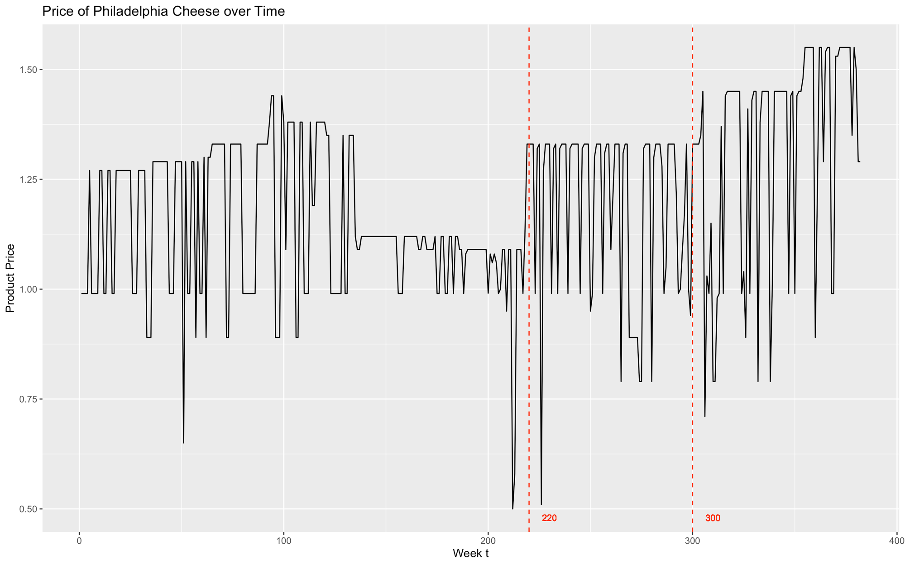

Appendix 4. Price of Philadelphia cheese between t = 220 and 300

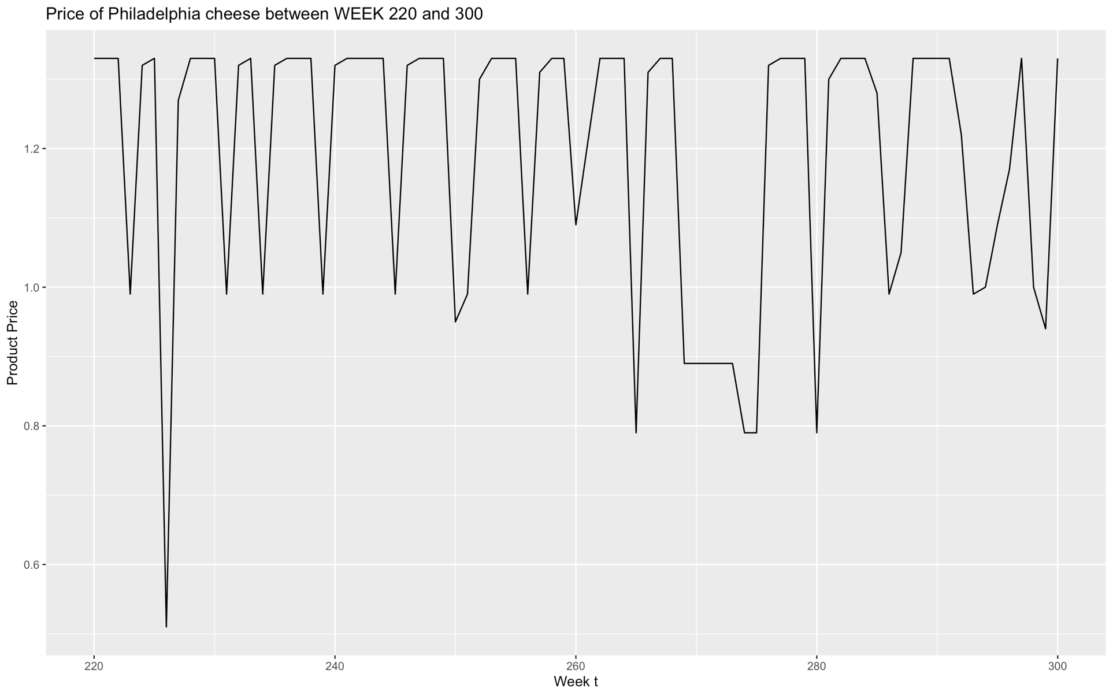

Appendix 5. Price trends after re-assigning prices based on the pseudo price ladder

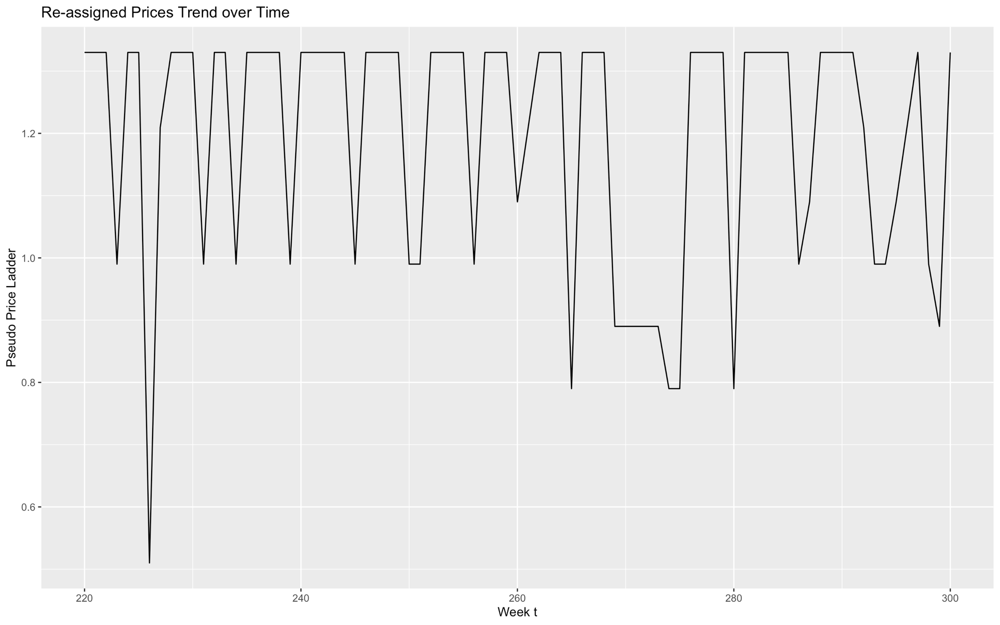

Appendix 6. Observed time periods between promotions after prices were re-assigned based on pseudo price ladder

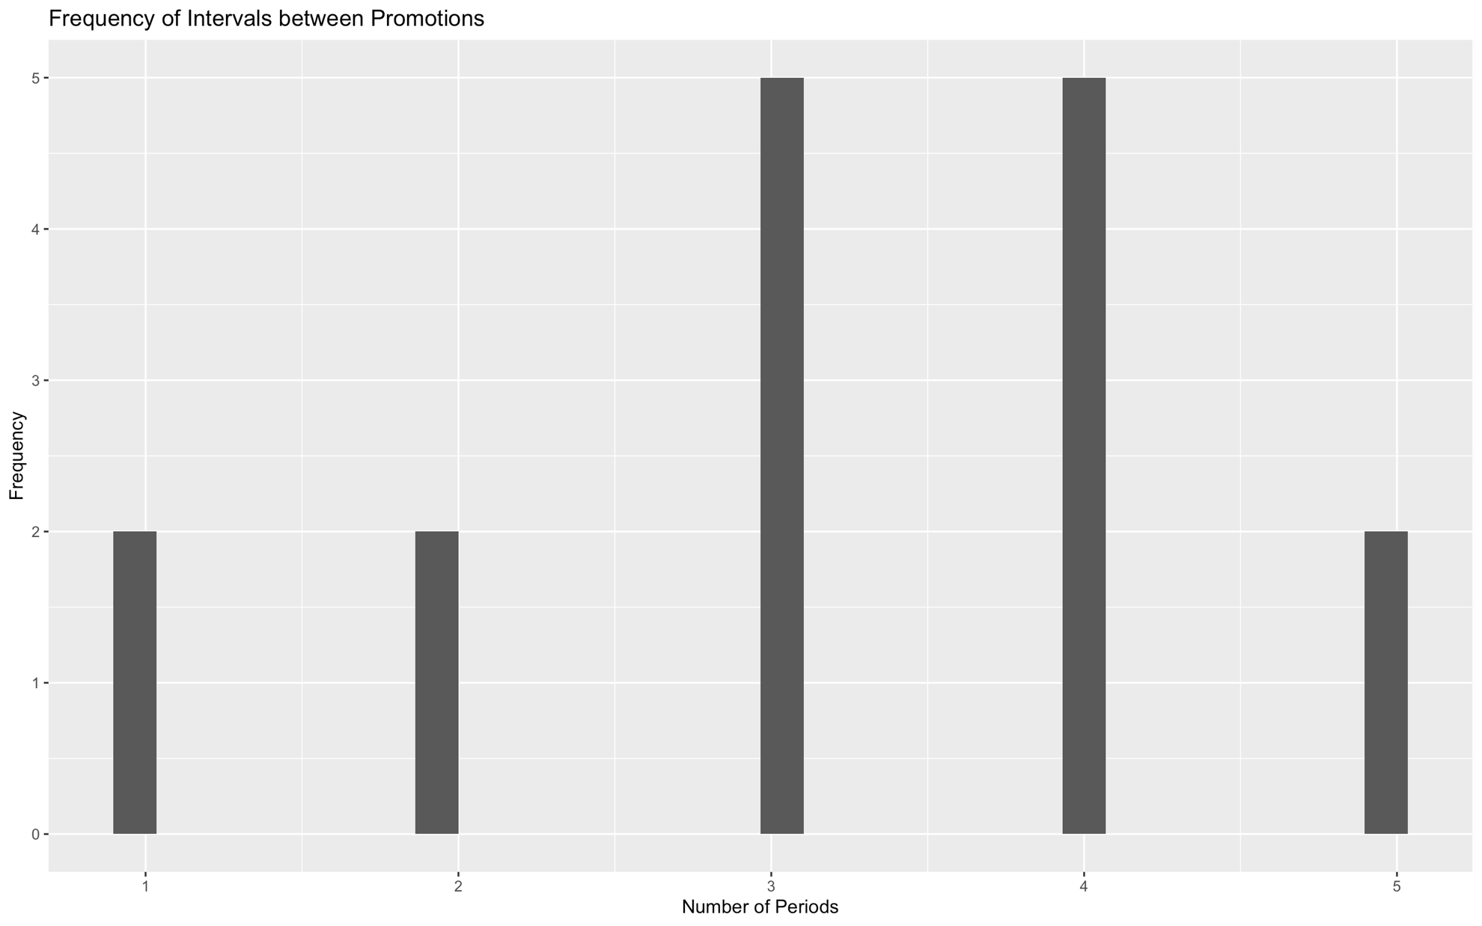

Appendix 7. Implied unit cost over time in the optimisation period

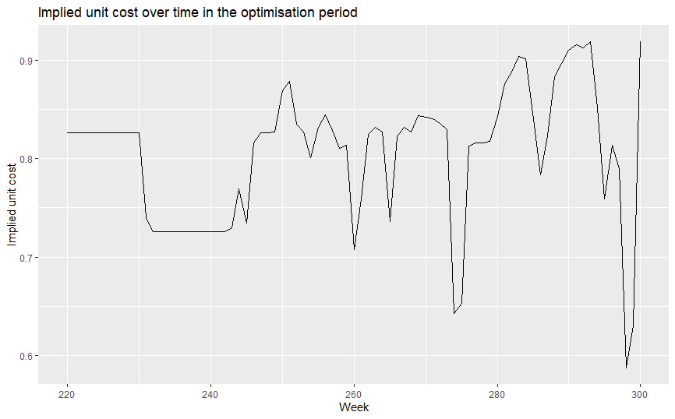

Appendix 8. Empirical prices, quantity sold and profit

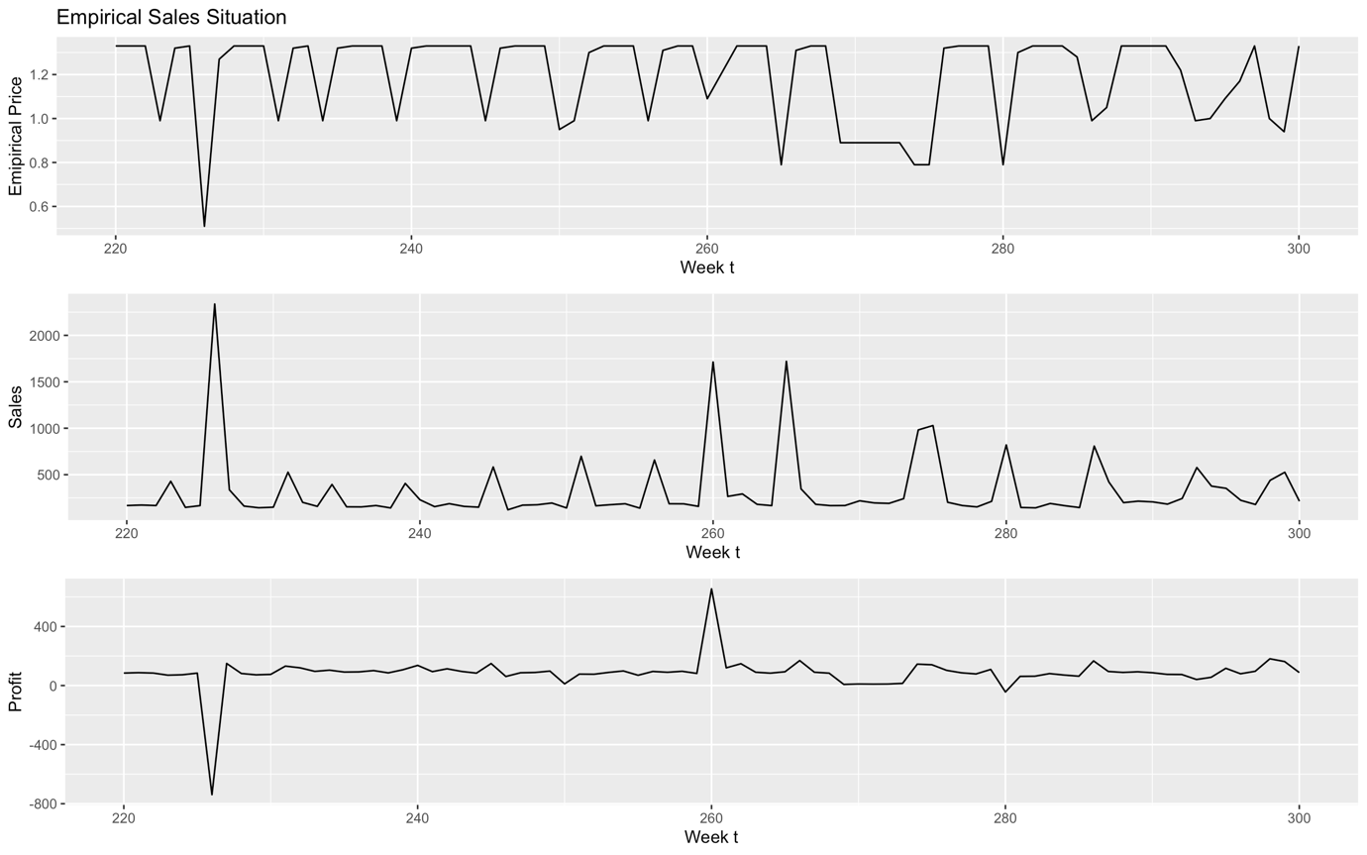
Appendix 9. Expected prices, quantity sold and profit with optimisation

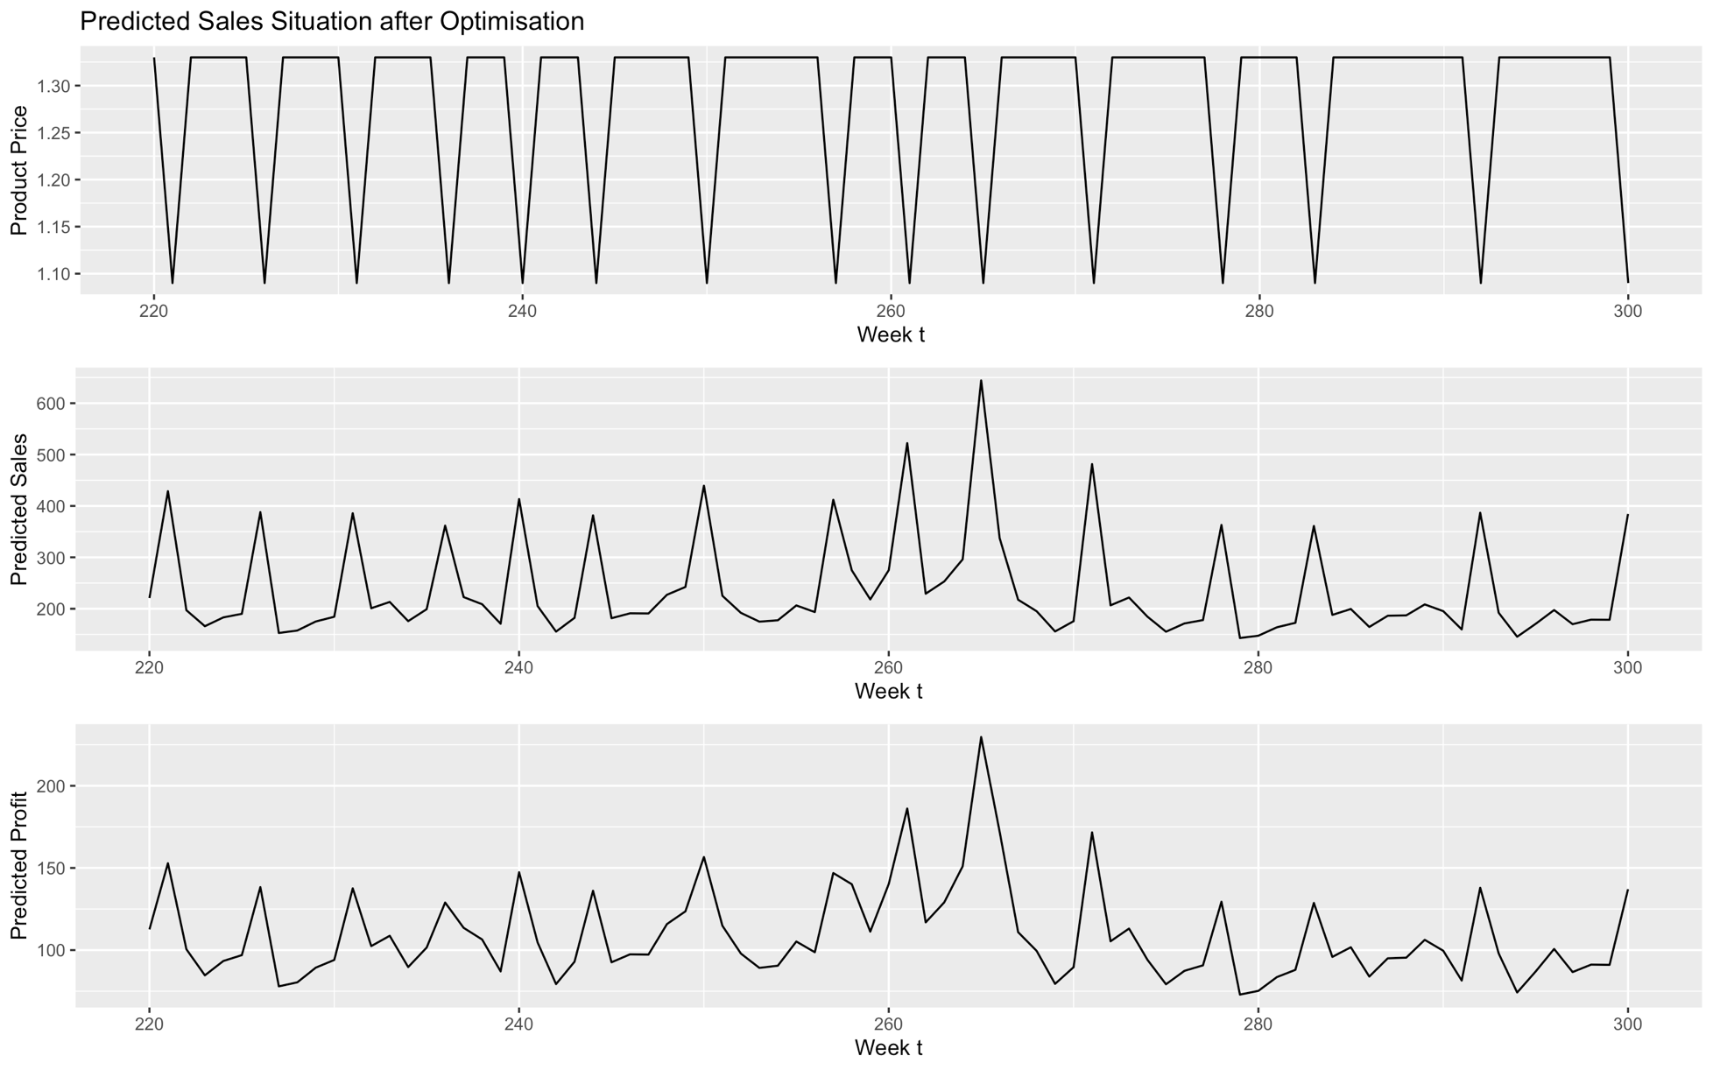

There is a slight difference in the specification of the error term between Cohen et al. (2017) and our model. However, this difference is not the focus since the error terms were not used for further analysis.
UPC codes are used to identify the manufacturer and the product.
QTY is 1 for all observations, thus PRICE equals to the unit price, and MOVE is the true sales quantity.
The highest number of cluster centres which gets rid of <0.05 variations around cluster centres is 7 clusters.

